EXPERIMENT – 10
CREATE A CLONING OF A VM AND TEST IT BY LOADING THE PREVIOUS VERSION/CLONED VM USING VIRTUAL BOX.
Aim:
To create a clone of a Virtual Machine in VirtualBox and test it by loading the cloned VM

Output:

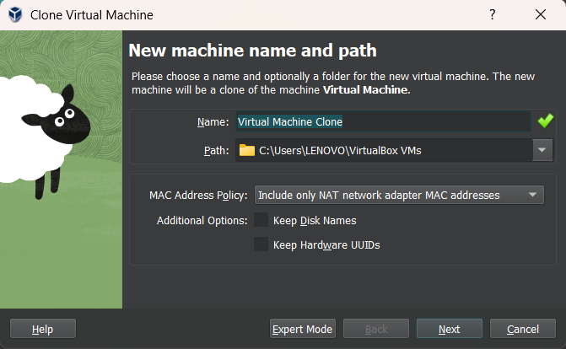
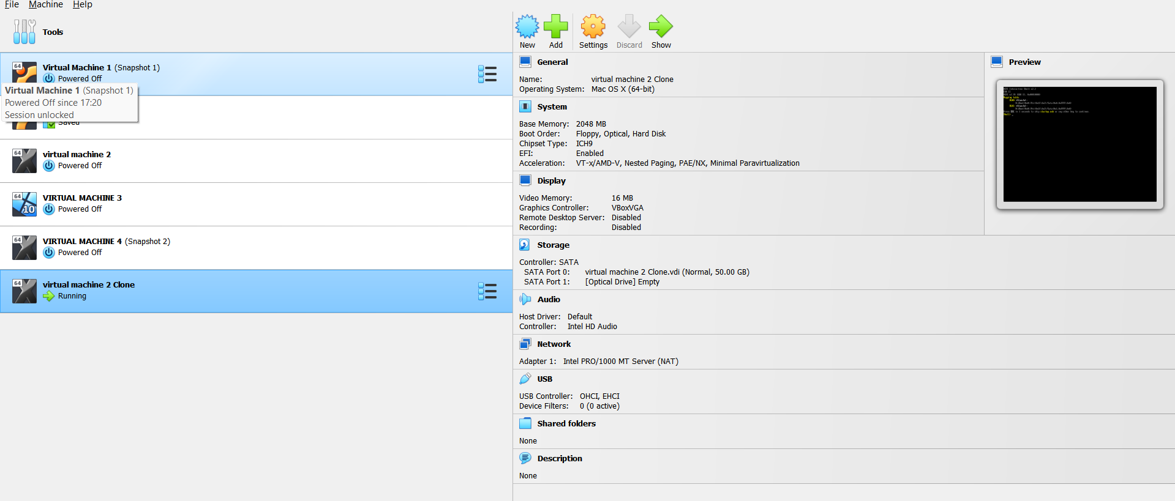

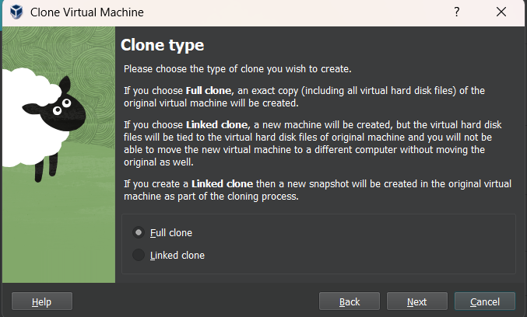

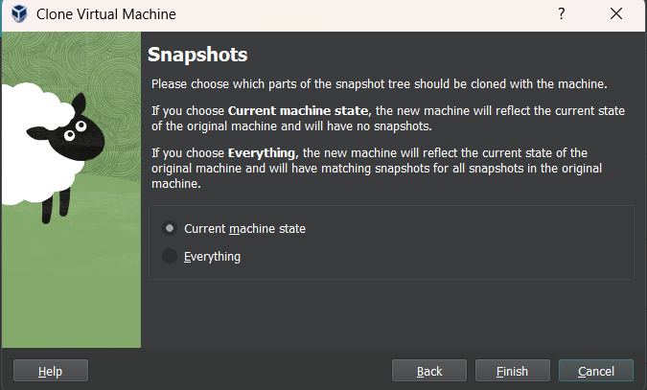
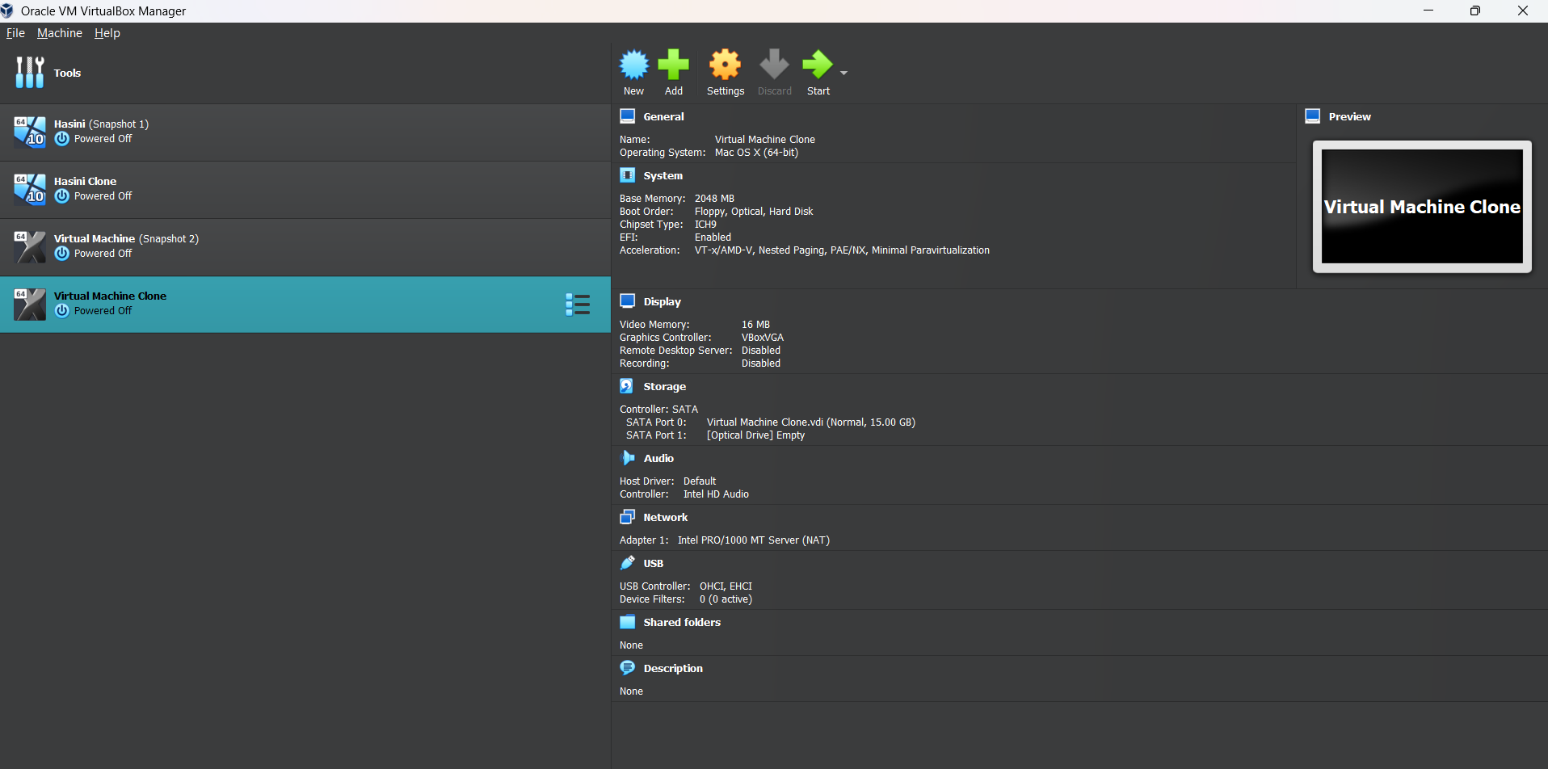
Result:
The VM was successfully cloned in VirtualBox. The cloned VM started and functioned correctly, demonstrating independent operation and the cloning feature for testing or backup purposes.

